**New topic:**

**Engineering Village Overview**

Engineering Village is the information discovery platform of choice for the engineering

community. In a single interface, researchers get access to today’s most important

engineering content.

Engineering Village links to multiple engineering literature databases from a range

of trusted sources: Scholarly journals, trade publications, patents, government reports,

reference books, conference proceedings, and more. Hyperlinked records and full-text

links give researchers meaningful results through a more comprehensive view of the

information. Powerful search tools plus an intuitive user interface boosts research

productivity.

**Second draft of Cited by topic:**

**Cited by Count from Scopus**

The Cited by count appears in each Compendex article that contains one or more citations

within Scopus. Following is an example of a Cited by count:



The number of documents that cite the article appears in parentheses, as shown in

the example. If an article has no citations, the Cited by feature does not appear.

However, it does appear for all EV users, regardless of their Scopus subscription

status.

When you click the Cited by link, a window appears where you can view a list of articles

that cite the current article. Non-subscribers of Scopus can view all articles on

the Scopus Preview page with limited functionality.

**Viewing the Article's Abstract**

Click the Abstract link to see an abstract of the article similar to this:

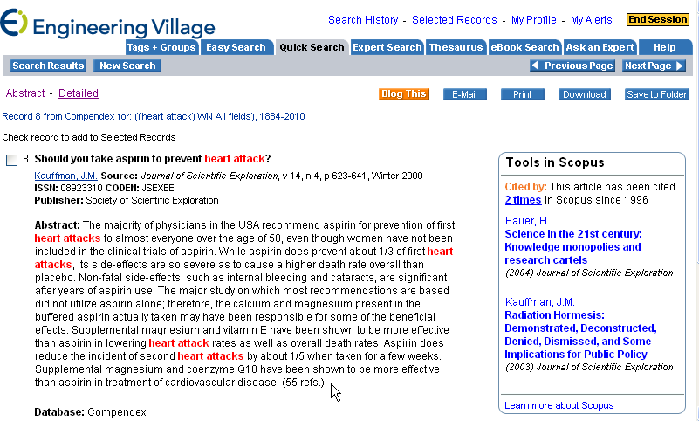

**Opening Scopus from EV**

Under Tools in Scopus, click the number of times (in this example, 2 times) to open

Scopus and use additional functions, as shown below:

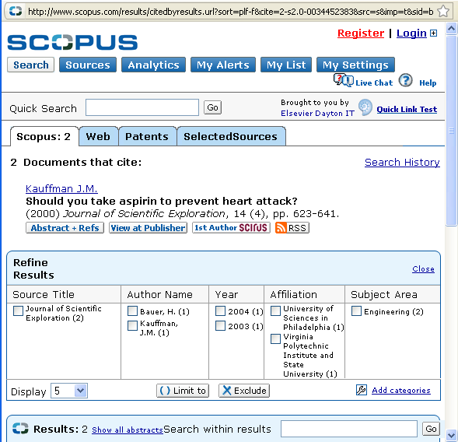

**Other Views Possible**

**Detailed** - Click Detailed (beside the Abstract link) to see the abstract plus an

easy-to-read list of details, including the abbreviated source title, language the

article is written in, and the number of references in the article.

**Article title under Tools in Scopus** - Under Tools in Scopus click the hyperlinked

title of the article to open a Scopus view similar to the one shown above.

**Learn more about Scopus** - Under Tools in Scopus click this link to gain a better

understanding of the Scopus application.

For more information about Scopus, go to http://info.scopus.com/about/